* Design a program for creating a machine which accepts string having equal no. of 1’s and 0’s
* CODE:

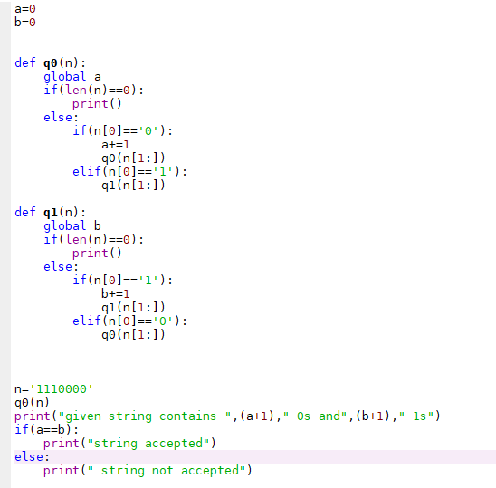

* OUTPUT:

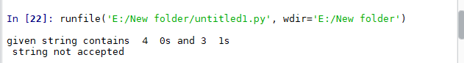

* CODE:



* OUTPUT:

